**Labs + Tests User Guide**

**Labs + Tests User Guide**

**TABLE OF CONTENTS**

**Where to Find Help**

Frequently Asked Questions and Help Resources .................................................. 3 **Labs +Tests — Feature Overview**........................................................................... 3

**Getting Started with Labs + Tests**

Step 1 **–** Sign in to Labs + Test......................................................................... 4 Step 2 – Access Labs + Test............................................................................. 4

**Self-Entered Tests** ................................................................................................ 5 **VA Lab Tests** .......................................................................................................... 6 **View Lab Test Results in the VA Blue Button Report and VA Health Summary**........... 8

2

**Labs + Tests User Guide**

**Where to Find Help**

**Frequently Asked Questions and Help Resources**

1. Select **FAQ** to go to **Frequently Asked Questions** and get commonly asked questions and answers about Labs + Tests.

2. Select **Help & User Guides** for guidance on using My HealtheVet.

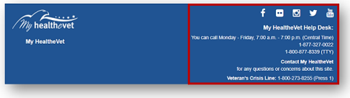

3. Select **Contact** to send a message to the My HealtheVet Help Desk or call 1-877-327- 0022. For TTY, call 1-800-877-8339 or dial 711.

**Labs + Tests — Feature Overview**

LABS + TESTS let you enter and record your lab work/test results. If you are registered on My HealtheVet as a VA Patient with an **upgraded account** , you can view your VA Chemistry/Hematology and other VA lab and test results as they become available.

Chemistry tests show how well certain organs are working. Blood chemistry tests may also be called chemistry panels. Common labs include blood sugar, cholesterol, calcium, liver function, thyroid tests, and more.

Hematology is the study of blood and blood disorders. These tests can evaluate a variety of blood conditions including infection, anemia, inflammation, blood-clotting disorders, leukemia and the body's response to chemotherapy treatments.

Chemistry/Hematology tests results are available thirty-six (36) hours after they have been verified by your VA health care team or other authorized VA staff.

Back to Top

3

**Labs + Tests User Guide**

**Getting Started with Labs + Tests**

**Step 1 – Sign in to Labs + Tests**

1) Sign in to your My HealtheVet account by selecting the **Sign in** button on the upper right side of the screen. You must have already registered for a My HealtheVet account. If you do not have a My HealtheVet account, please register by selecting the **Register** button and completing the registration form. 2) Sign in using a Sign-In Partner: My HealtheVet Premium Sign-in Partner, DS Logon Premium Account, or ID.me.

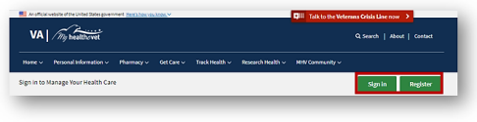**Step 2 – Access Labs + Tests**

After signing in, there are two ways you can access Labs + Tests:

1) Select **Labs + Tests** from the **Track Health** drop-down menu

2) Or, Select the **Labs + Tests** on the dashboard to quickly view the results 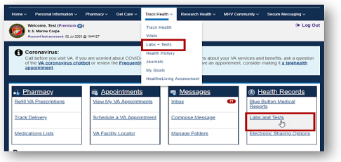Back to Top

4

**Labs + Tests User Guide**

**Self-Entered Tests**

On the Labs + Tests page are test logs. These logs include your **Self-Entered TESTS** and your **VA CHEMISTRY/HEMATOLOGY**. Each log gives you a quick glance of information and displays the five most recent entries.

**Note:** VA Chemistry/Hematology information comes from your VA health record. You *cannot* change or add information to your VA Chemistry/Hematology log. If you have a question about a VA lab result, contact your VA health care team or other authorized VA staff.

**Step 1 – Self-Entered Tests**

1) Select the **Add New** button to add a new test entry

2) Select the **View More** button to expand the list

3) Or, select **Self-Entered Tests** from the quick link panel to view the expanded list and add an entry

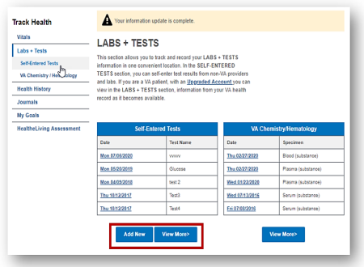4) After selecting the **Add New** button, complete the fields on the next page.

Back to Top

5

**Labs + Tests User Guide**

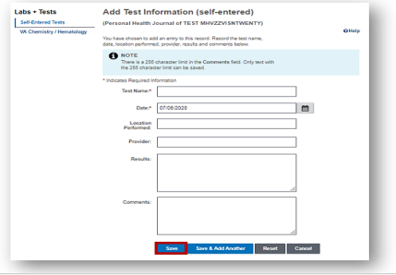

5) Select the **Save** button.

**VA Lab Tests**

**Step 1 – Chemistry/Hematology Tests**

As a reminder, your Chemistry/Hematology tests results are available 36 hours after they are verified.

1) Select the **View More** button to view additional Chemistry/Hematology test results. Back to Top

6

**Labs + Tests User Guide**

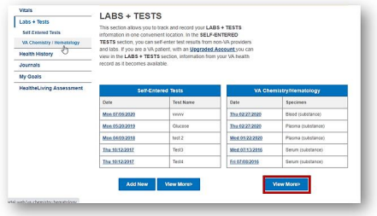

2) Or, select **VA Chemistry/Hematology** from the quick link panel to view the expanded list.

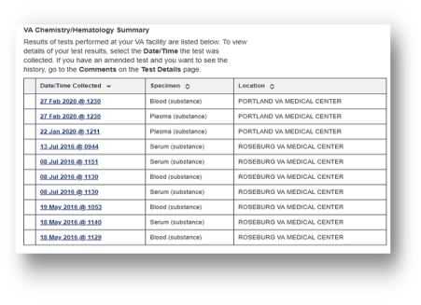Back to Top

7

**Labs + Tests User Guide**

**View Lab Test Results in the VA Blue Button Report and VA Health Summary**

• **VA Blue Button Report**: Select the date range to download or print your partial or full history of VA lab tests and self-entered results.

• **VA Health Summary**: You may want to use this option if you are sharing health information with a non-VA provider in the community. It includes your ten most recent sets of lab tests over the past 24 months.

Once your lab results are available in your My HealtheVet account, all three reports will list them by the date and time they were collected beginning with the most recent. The VA Blue Button Report is the most common way to view your results.

In the VA Blue Button Report version, it shows the name of the lab work/test performed, the date it was performed, the location, the provider who ordered/performed the work, and the results/reference ranges. See the report example below:

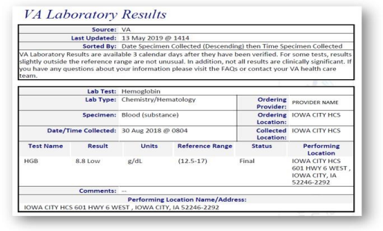**Interpreting Results**

In the example above, 'HGB' is the (hemoglobin) blood test; the result is 8.8; the reference range is 12.5 to 17. While some lab results provide a simple 'positive' or 'negative' answer, others have numbers and values. Their meaning comes from their comparison to the reference range values.

Back to Top

8

**Labs + Tests User Guide**

A reference range provides you with the upper and lower limits of a lab test based on a group of otherwise healthy people. By comparing your test results with reference values, you and your health care provider can see if your test results fall within or outside the range. A result outside the range of expected values does not mean you are sick, but it does alert your health care provider of a possible health-related problem.

For some tests, results slightly outside the reference range are not unusual. In addition, not all results are clinically significant. If you are unsure about what your result means, your VA health care team or other authorized staff may have entered in the **VA Notes** (sometimes called Progress Notes) to help you understand the information.

You can also use the **Secure Messaging** feature of My HealtheVet to easily contact your VA health care team.

Back to Top

9